Fall 2021

Anthony Feliciano

University at Buffalo

Social Distancing Alarm

CSE 321 Embedded Systems

Project 3

Introduction

This is the report for the third project assigned in the class CSE 321 Embedded systems at the University at Buffalo. The goal of the project was to make a social distancing alarm in which a sensor is used to gauge distance and alert the user when a person gets too close to the sensor. The project is intended to help people from spreading viruses like the flu or covid-19.

Specifications

The specifications are as follows:

Inputs ports:

* PD_7
  + Used for Trigger of rangefinder
* PD_6
  + Used for echo of rangefinder
* BUTTON 1
  + This onboard button is used to turn on the buzzer functionality of the project

Output ports:

* PB_8
  + This pin will supply be used to output power to the buzzer
* PC_8
  + This pin will be used to output power to the LED on the breadboard

Features

* Ultrasonic rangefinder detects objects that are within 100cm
* If object is with 100 cm of the rangefinder a buzzer is set off along with an external LED
* User may press button 1 to turn on or off the alarm from sounding
* Initially alarm is off

Block Diagram/schematic

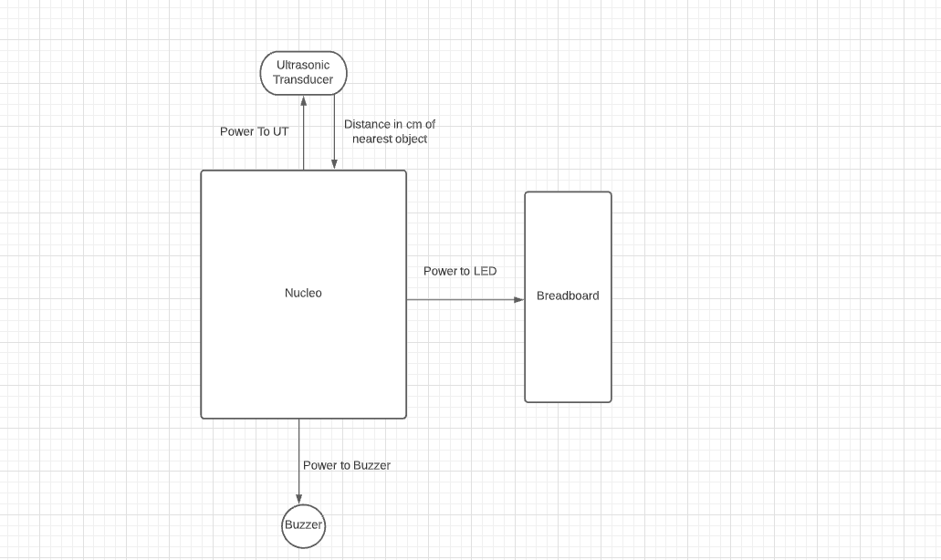

State Diagram

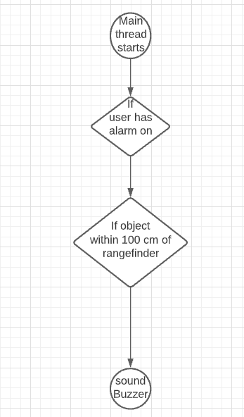

Applications

The applications needed are as follows:

* Mbed Studio(IDE)
* mbed.h
* hcsr04.h

BOM

* Nucleo**-L4R5ZI**
* **USB A to Micro USB B cable**
* **1 LED**
* **1 resistors**
* **male to male jumper wires**
* **female to male wires**
* **Ultrasonic transduce(HCSR04)**
* **Buzzer**

User Instructions

**Ultrasonic rangefinder set up:**

* Attach female to male wire to PD7 and to trigger of rangefinder
* Attach female to male wire to PD6 and to echo of rangefinder
* Attach female to male wire to 5v and to VCC of rangefinder
* Attach female to male wire to GRD and to GRD of rangefinder

**Buzzer set up:**

* Attach female to male wire to GRD and to GRD of buzzer
* Attach female to male wire to PB8 and to I/0 of buzzer
* Attach female to male wire to 3v and to VCC of rangefinder

**LED set up:**

* Attach male to male wire to bread board and to GRD of Nucleo
* Attach male to male wire to bread board and to PC8 of Nucleo
* Attach resistor to negative portion of LED and connect to GRD

How to use:

* Load code onto board via mBED studio
* Press on board Button 1 on Nucleo to turn on alarm

Test Plan

Testing should be done simply using LED’s to test for power.

Pressing Button 1 should light up the LED attached to the breadboard.

If it doesn’t light up check your connections.

After the LED lights up after button press point the rangefinder at yourself

and listen for the buzzer going off.

Results

The result of the project was a rangefinder that detected object within 100 cm of the rangefinder and alerted the user about it.

Recommendations for improvement

One of the things that can be improved is the way that the range finder identifies objects. Originally it is supposed to identify only people. However due to the nature of the rangefinder it can go off if it detects any object within 100 cm. This can be improved by adding a temperature sensor to detect the temperature of an object as well as the range.